Food Safety Management System (HACCP) Based on the ISO 22000: 2018
Food Safety Management Systems

Workshop

PARTICIPANT MANUAL

PREFACE

KEY LEARNING PRINCIPLES

Before we begin this training course it is important we keep in mind some important concepts about adult learning. These points will help us all learn more and will contribute to a better sharing of the knowledge contained in this training course.

The first concept to remember is that learning is a process. From this we need to understand that learning does not happen in isolation e.g., at today’s training event or at first reading of this material. Instead it involves how you as the learner relate and even adapt this learning to your work and home environments. Once we recognize that learning is a process we can then apply everything learnt to whatever situation is at hand.

The second concept to be aware of is that we all learn in different ways or possess different styles of learning. Although this may seem like an obvious point, it has many important implications for the session today. As the training progresses the trainer will ask ‘is everything OK so far’ or ‘do you understand everything so far’ and many may state that they are happy with the progress. However, it is quite likely that all participants may not be learning in the same way or at the same pace.

As a result don’t be afraid to ask questions because what might be easy to some may be harder for others and vice-versa. It is also important to have patience if you feel the course is going to slow as it may actually be too fast for others. We all never know when we personally may need some extra time to understand things and will appreciate others support when this happens. What is important today is that everyone learns and hopefully meets their expectations from the course.

The third concept to recognize is that learning is improved when it is goal-directed. Research has consistently demonstrated that when clear goals are associated with learning that the learning occurs more easily and rapidly. To illustrate, people who learn to drive so that they can get to and from work generally find the experience easier and apply themselves to reach this end.

Fourth, active participation improves the learning process. Research has also shown that by actively participating in training events that it improves how learning is achieved and how long information is retained. As a result don’t be afraid to get involved or to make a mistake. After all mistakes are some of the best examples of learning and creativity in the world.

Finally don’t forget to be open to learning. No matter what you current knowledge and skill levels within this area it is essential that you are prepared to learn from the course and the other participants. It is also very likely that you have knowledge and experiences that could benefit the other participants and even the trainer. Please share what you can as it will make the course more rewarding for all concerned.

Having introduced the main concepts of adult learning, it is now necessary to apply them to your own learning - both within your working environment and outside life. Research suggests that the best way to do this is to develop an action plan that clearly represents your goals and how you plan to achieve them.

At the end of this training you will be requested to complete a short action plan that will help you guide your ongoing achievement of your goals. Please note that this is included as a guide and you are free to add or substitute aspects to meet your own unique goals. You are also free to complete this plan after the course is over if you would prefer. Please remember that since all answers given are only for your use that it is advisable that you answer them as accurately and honestly as possible.
All we can do now is to wish you the best of luck with your learning and hope that you find this course beneficial.

Section

1
Session 1 –
Good Manufacturing Practices

GENERAL OVERVIEW

Building an effective food safety system requires the establishment and maintenance of appropriate good practices which provide an environment conducive to producing safe food. In a food manufacturing setting, these practices are often collectively referred to as Good Manufacturing Practices (GMPs). There are many GMPs which a food safety manager must effectively manage. The design and management of a facility and the surrounding environment is important to minimize the risk of contamination in food products. The materials used to construct the facility, its design, maintenance, and location should all be taken into consideration when developing and implementing a food safety management system. Similarly, there are GMPs pertaining to other critical food safety elements such as control of food plant operations, transportation, appropriate labeling, and employee training.

This section covers a subset of GMP requirements described in the Codex Alimentarius General Principles of Food Hygiene.

The following topics will be discussed:

- Establishment – Design and Facilities

- Control of Operation

- Storage and Transportation

- Product Information and Consumer Awareness

- Training

Establishment – Design and Facilities

Section Overview

The management of a facility and the surrounding environment is important to minimize the risk of contamination in food products. The materials used to construct the facility, its design, maintenance, and location should all be taken into consideration when developing and implementing a food safety management system.

This learning module covers the requirements for effective control and management of your facility’s environment.

The following topics will be discussed:

- system development

- location

- maintenance of surroundings

- design and layout

- facility construction

- maintenance of facilities

- storage

- windows and doors

- lighting

- monitoring of facilities

Learning Objectives

At the conclusion of this section, the learner will be able to:

- List primary considerations when developing a system to effectively manage food establishment design and maintenance of facilities,

- List and describe factors to consider when evaluating the location of a food establishment,

- List and describe requirements for maintenance of the environment surrounding a food establishment,

- List the primary factors to consider in designing a good facility for safe food production, and describe the manner in which these factors can reduce the risk of contamination,

- List and describe appropriate considerations for materials and equipment used in the food establishment and how these choices help minimize the risk of product contamination,

- List key considerations for maintenance of the facilities at the food establishment, describe considerations for safe storage and transportation practices,

- Describe appropriate design considerations for windows and doors to minimize food product contamination,

- Describe the lighting requirements to facilitate safe working conditions and to enable effective food safety management, and

- List the primary considerations for effective monitoring of the facility to ensure it meets safety requirements.

SYSTEM DEVELOPMENT

As the person responsible for food safety within the factory it is important to develop a system to:

- train and monitor the staff on the maintenance of the facility surroundings

- train and monitor the staff on the internal maintenance of the facility

- monitor the design and layout of the facility

- monitor the materials used in the fabrication of the facility

- monitor doors, windows, and lighting used in the facility

Any system will have to be clearly and concisely documented and communicated effectively to appropriate staff within the company.
It is important to work closely with key company staff to ensure that they clearly understand the importance of such systems and the ways they can influence effective compliance.

Since the responsibility for food safety rests with you, direct verification of systems is extremely important. You should personally monitor activities on a regular basis and record your findings.

LOCATION

The site where the food facility is located is extremely important for the safety and quality of products. Products can easily be affected by factors outside of the facility. For example, activities carried out in adjoining premises may result in:

- dust

- smoke

- odor

- volatile compounds

- shared drainage

- harborage for pests

Proximity to rivers or waterways may also create problems, such as the potential for contamination in the event of flooding.

If you are unable to change the location of the facility or new factors which could affect the facility are introduced, you must put control measures in place to ensure that the safety and quality of the products are not compromised by the local environment.

The Control of Atmospheric Contaminates

Atmospheric contaminants such as dust, smoke, odor and volatile compounds can have an adverse effect on the safety and legality of your product.

If the local environment has any processes where these atmospheric contaminants can enter the facility and compromise the safety and quality of the products, then effective controls must be put in place.

Appropriate screening and sealing around doors and windows can help minimize the potential of dust entering the factory.

Where atmospheric contaminants such as odors that cannot be controlled by screens are the issue, then other controls can be used. You can install a ventilation system or move the vulnerable product to an area in the factory where contamination cannot compromise the product, for example, a sealed ventilated internal room.

Shared Drainage

Drainage that is shared with other local companies or private dwellings can be a serious product safety issue if the drainage system is inadequate or faulty.

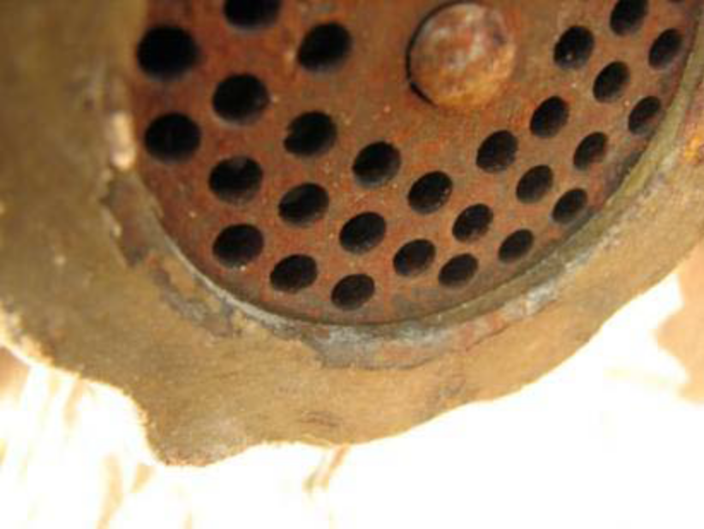
If the system is inadequate for the number of users or the types of materials placed into the drainage system, then blockages can result. This can create problems such as effluent overflowing into the facility and cause a serious contamination hazard or odor problem.

Faulty drainage systems must be repaired to prevent any blockages or odor issues. You should consider new drainage systems if shared drainage is the issue.

Harborage of Pests

The location of the facility and its surrounding area is important since pests may become a problem. Facilities that are near a water source or heavily-vegetated overgrown areas will have an increased risk of pests entering the facility, particularly at certain times of the year when their food sources and shelter may become scarce. If you are unable to change the location of the facility, then be sure to deny pests harborage. You must control and manage the external areas around the facility to reduce the likelihood of pest ingression and possible infestation. Pest control measures such as baiting for rodents at the perimeter of the factory should be considered.

When planning pest control measures, you also need to consider waste management procedures and the storage of materials used at the facility.

MAINTENANCE OF SURROUNDINGS

Maintaining a factory’s external conditions is also important to prevent the harborage and possible ingression of pests. Also, it is important in regards to eliminating possible contamination from any movement of product through the factory site.

You also need to consider the visual impressions the site creates. The proper care of the external condition of a factory helps you maintain customer respect and continued high staff morale.

Storage of Equipment and Waste

Where possible, there should be no external storage of equipment or materials. However, when equipment needs to be stored outside the factory it should be stored in a manner to eliminate any risk of contamination of the product, carefully inspected on a regular basis, and cleaned before use.

In some cases, materials such as packaging may be stored externally but you should take measures to protect the material from contamination. The material must be regularly monitored for contamination by foreign materials or infestation by pests.

Where raw materials are stored in silos external to the production area, these need to be maintained to the appropriate hygiene standards, protected against pest infestation, and regularly inspected.

Maintenance of Roads, Yards, and Parking Areas

Roads, yards, and parking areas must be maintained to an appropriate standard to prevent contamination of products. Particularly in dry areas, roads, yards, and parking lots can have problems with dust which can be swept up by vehicles and blown into the facility. Keeping these areas free from a build-up of grit and dust will significantly reduce the risk of contamination. Good maintenance of these areas will also reduce the risk of staff carrying any contamination on shoes or clothes into the food production areas.

Drainage and Treatment of Waste

Surface water drainage should be designed so that the surface water is diverted away from the facility as quickly as possible. Correcting any drainage problem is particularly important where high levels of rainfall occur. There should be no area in close proximity to the facility where surface water doesn’t drain appropriately and is able to accumulate.
Any waste treatment and disposal systems should be outside the facility and as far away as possible from the production and storage areas.
The waste treatment and disposal systems should be operated properly and pose no risk of product contamination either by atmospheric contamination, physical contamination, or pest infestation.

DESIGN AND LAYOUT

The design and layout of a facility is important to minimize the risk of product contamination due to poor personal hygiene practices or exposure to microbiological, chemical or physical hazards. This section shows how good facility design and layout can reduce the risk of contamination.

The areas considered in this section include:

- equipment placement and storage of materials

- points of entry

- hand-washing facilities

- toilet facilities

- water supply and waste water systems

- the design of the facility to reduce contamination of products.

Equipment Placement and Storage of Materials

The facility should be clean and tidy with adequate space to enable correct use and maintenance of the equipment. If a lack of space results from workstations being untidy or restricted, or equipment itself being too large for the work area concerned, then it may be difficult to clean these spaces adequately.

Factory housekeeping practices should ensure that materials are stored away from workstations so these areas are kept tidy and unrestricted to facilitate adequate cleaning.

Points of Entry

Where possible, the facility should have a single point of entry for staff and a single point of entry for raw materials and ingredients. This will minimize the amount of cross contamination between staff, raw materials, and finished product. If your facility has more than one point of entry, then you should consider cordoning off the other points so staff and visitors use only one entrance.

Good practice dictates that all staff facilities such as changing rooms and canteens should be in the immediate proximity of this entrance. All visitors to the factory should be directed to this point of entry.
Hand-Washing Facilities

Staff and visitor hand-washing procedures are extremely important. Hand-washing is considered the most important aspect of personal hygiene to minimize the risk of microbiological contamination.

Hand-washing facilities should be adequate in number and be supplied with hot and cold water, soap, and have appropriate provisions for hand drying. Single use towels or hot air blowers are acceptable means of hand drying, but multi-use towels are not acceptable due to the potential for cross-contamination.

The number of wash basins should reflect the number of staff working at the facility. In many countries there are legal requirements for the ratio of the numbers of wash basins to the number of staff.

The location of wash basins is also important. Staff members are more likely to use the wash basins if they are situated at the entrance to a production area. Hand-washing facilities should also be placed in particularly dirty areas or high-risk areas so that staff have the opportunity to wash their hands on a regular basis.

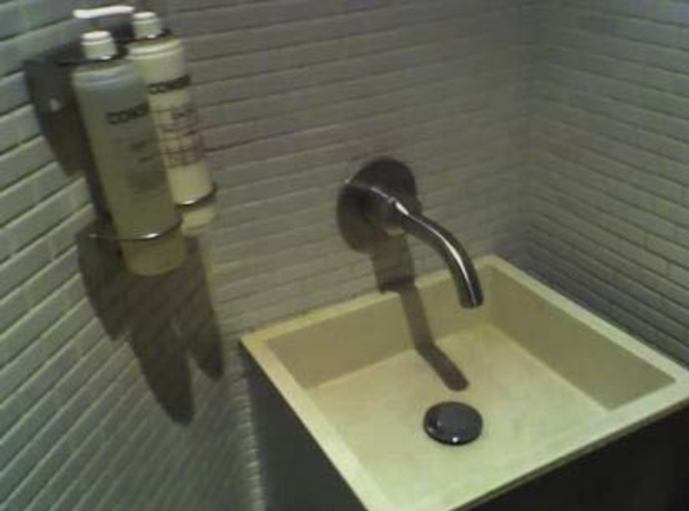

Toilet Facilities

There should be an adequate number of toilets for the number of staff working in the facility.

The toilets should not open directly into a food preparation area. Jurisdictions typically have building codes which specify the required characteristics of toilet facilities, including the numbers of doors or other barriers between the toilet and food preparation areas.

The toilet areas also should have hand-washing facilities supplied with hot and cold water, soap and hand-drying equipment available. Signs informing staff of the need to wash their hands before leaving the toilet area should be placed in easily visible places.

The toilet area should be cleaned and disinfected on a regular basis. It is good practice to post a cleaning schedule so that there is a record of when cleaning has taken place. As a food safety manager, you should ensure these areas are inspected and monitored on a regular basis to verify the effectiveness of the cleaning procedures.

Water Supply and Waste Water Systems

The factory water supply should be adequate with respect to quantity and quality of water, and always be derived from an appropriate source. Water that comes from a private source, such as a well or natural spring, must be tested for microbiological quality and other possible contaminants. Good practice dictates that water must be tested at least once per year if it is derived from a properly constructed well or treated municipal water source, but actual testing frequencies for water by a facility should be based on a risk assessment. Any problems with the safety of the water supply should be corrective immediately.

Waste water systems from the factory should be adequate in size and design to prevent the possibility of used or foul water flowing back into the factory and causing significant risk to health.

If production increases at your facility, make sure the incoming water supply is able to accommodate this increase. Measures may need to be taken to ensure the quality and quantity of water is still adequate. Adequacy of waste water systems must be also be considered if there is an increase of waste water volume produced by the facility.

Backflow Prevention

Backflow is defined as the flow of water or other liquids, mixtures, or substances into a potable water system from any source, other than the intended source.
A cross connection is defined as any connection or structural arrangement between a potable water system and a non-potable source, liquid or otherwise, through which backflow can occur.

Water systems must be designed in a manner that minimizes the risk of backflow of non-potable water or waste into the potable water system. This design will typically require the use of air gaps, air breaks, and backflow prevention devices.

Design to Reduce Contamination of Products

A facility can be carefully designed so that the number of possible food contact surfaces is reduced, therefore minimizing the risk of product contamination.

The physical separation of foods, either by the use of designated areas or the movement and control of packaged raw materials, will also significantly reduce the risk of cross-contamination.

Where possible, workflow should be linear and progress in a uniform and logical direction from raw material to finished product. The movement and separation of staff is an important factor in reducing risk of contamination, particularly in relation to high-risk foods or where allergen control is deemed important. Good practice procedures such as color-coding the different work areas, having staff wear protective clothing, and implementing quick and thorough cleaning of equipment and process utensils are policies staff must follow.

FACILITY CONSTRUCTION

The materials used in the construction of the facility also are fundamentally important to minimize the risk of product contamination. Inappropriate or inadequate materials used in the facility construction can lead to product contamination or a reduction in quality of products.

This section looks not only at the construction of elements in a facility such as floors, walls and ceilings, but also at the equipment and the ventilation systems used within the facility.

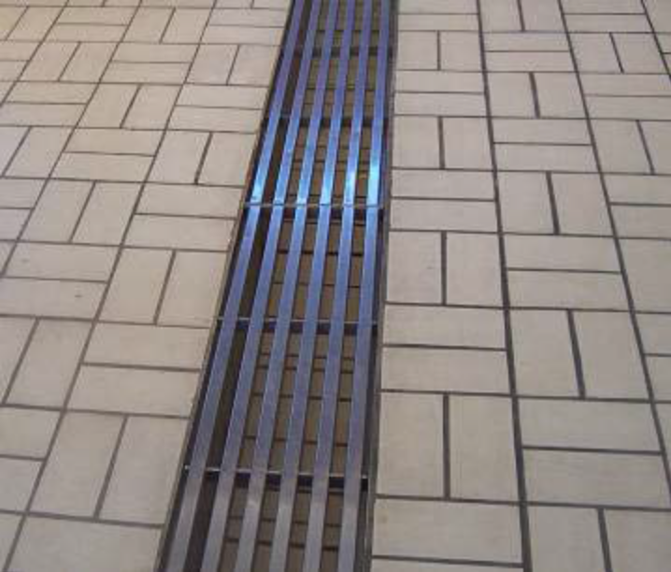

Materials and Design of Floors, Walls, and Ceilings

Ceilings should be smooth, clean, fire-resistant, non-flaking, light-colored, covered at wall joints, and easy to clean.

Walls should be clean, smooth, impervious, non-flaking, durable, light-colored, and capable of being thoroughly-cleaned or disinfected. Surfaces should be resistant to spillages, chemicals, grease, heat, and impact.

Floor surfaces should be clean, durable, non-absorbent, anti-slip, free from crevices, and capable of being effectively cleaned. Depending upon the products processed, floors may need to be resistant to acids, grease, and salts, and, where necessary, should slope sufficiently for liquids to drain to trapped gullies.

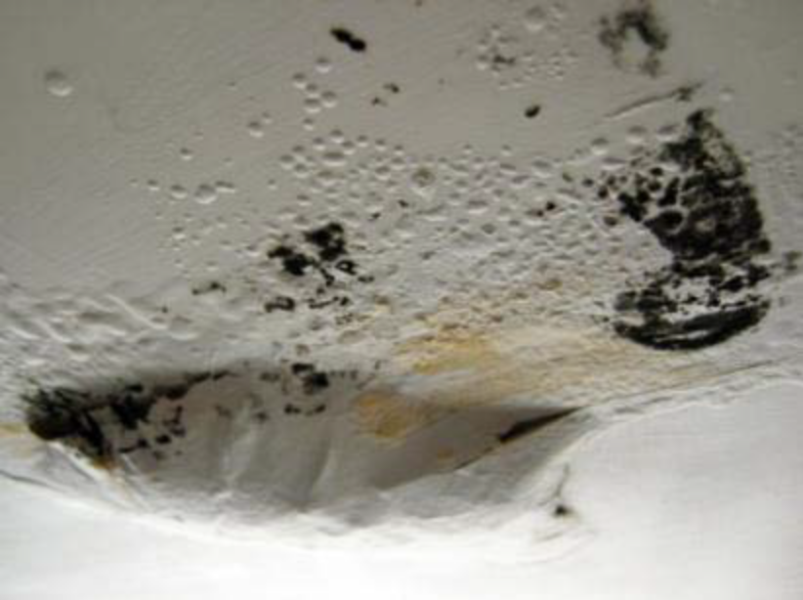

Contamination from Condensation

Some food manufacturing processes such as canning or cooking can lead to the generation of a large amount of condensation in the facility. This condensation may represent a high risk of contamination if it drips from pipes or other surfaces into unprotected product. Appropriate measures should be in place to prevent this source of contamination. If possible, no pipes should be located directly over unprotected products in order to eliminate the contamination risk. If this is not possible, product should be suitably protected by the use of covers.

Note that any surface which from which condensation can drip into an open food product is generally considered to be a “food contact surface.”
Condensation also poses a significant microbiological risk, particularly in relation to high-risk foods. Food should be protected from any condensate formed from chilled air units.

Where processes such as steam heating may cause high levels of condensation, appropriate ventilation should be used to control and vent steam away from product.

Ventilation

Where there is a risk of foreign body contamination, such as dust or dirt particles or atmospheric contamination from odors or volatile compounds, there should be adequate ventilation systems in place.

When designing ventilation systems, you should take care to ensure that there are screening or filtration systems incorporated into the ventilation systems to prevent other contaminants such as insects from entering the factory.

When ventilation systems are incorporated into the factory, these should be included in the factory cleaning schedules.

Protection from Pests

The construction of the building and its maintenance should be such as to prevent the entry or harborage of pests such as rodents, insects, and birds.

Building materials that are joined or seamed should have no gaps. Piping or ducting entering or exiting the factory should be sealed.

The actual building design should not encourage roosting areas for birds or have large voids which are difficult to access and clean. For example, suspended ceilings allow food particles to accumulate and thus create ideal conditions for pests such as insects to live and breed without hindrance.

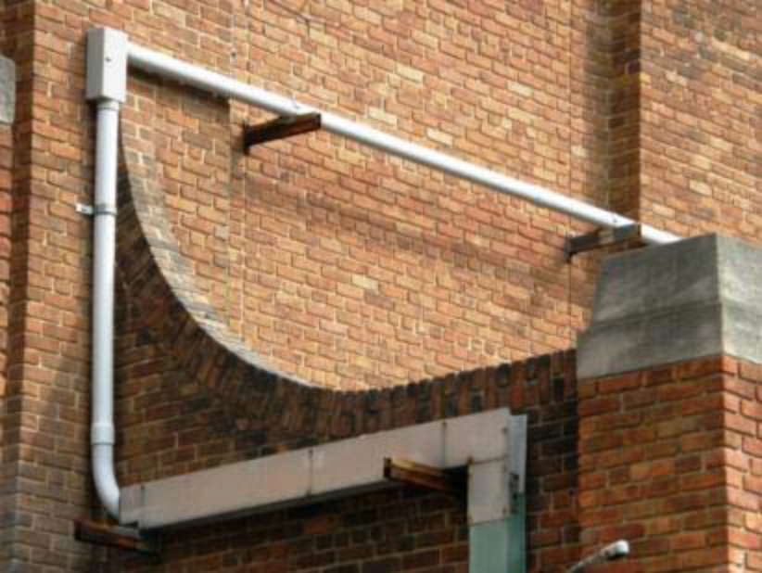

Food Contact Materials

All food contact materials should be non-corrosive and made of non-toxic materials. Most suppliers of food processing equipment will produce a certificate of conformance with the relevant legal requirements for food contact materials.

The equipment should be of sound construction, durable, easy to maintain and clean and, where appropriate, easy to disinfect.

All equipment which comes into direct contact with food should be regularly inspected to ensure that it does not pose any risk to food safety. With respect to high-risk foods, it is good practice to carry out regular swab checks to assess the microbiological populations on a particular work surface. The presence of significant populations of microorganisms on food contact surfaces could indicate that cleaning and disinfection procedures may need to be reassessed.

There are occasions when, if a piece of equipment that comes into direct contact with food has a highly damaged surface, the prescribed cleaning processes may be inadequate to fully sanitize the surface of the equipment. A good example is a meat cutting board where general cleaning processes undertaken during a production period are ineffective. In such cases, the equipment or utensil should be replaced, resurfaced or refurbished, as appropriate.

Seams of Food Contact Surfaces

Where there are seams or joints in food contact surfaces, these should be smoothly bonded and, where appropriate, sealed. Poor seams that are not smoothly bonded can provide an environment where food residues can accumulate and support the growth of bacteria. These areas are notoriously difficult to clean properly, so the risk of microbiological hazards significantly increases.

A primary area of concern involves food that is processed or conveyed within closed pipe systems. Poor internal surfaces formed around pipe seams and joints which cannot be appropriately cleaned can provide an environment where food residues accumulate and continuously contaminate food with bacteria. For this reason, it is particularly important to ensure that equipment and piping in food facilities doesn’t have any “dead ends” or other areas where food residues can be trapped.

MAINTENANCE OF FACILITY

As the manager responsible for food safety, you should ensure that regular inspections are carried out in relation to the condition of the facility and equipment. In the event it is determined that conditions in the facility could compromise food safety, you should undertake maintenance or cleaning action immediately to resolve any issues.

To ensure these inspections are carried out on a defined frequency, it is good practice to develop and maintain a schedule specifying where and when areas must be inspected for repair and the effectiveness of cleaning and sanitizing.

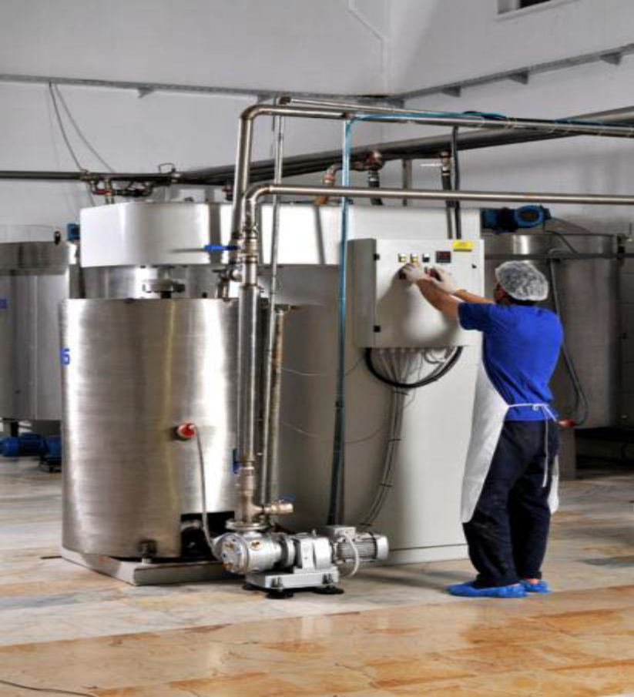

Sanitary Condition and Good Repair

Understandably, great emphasis is placed on food contact surfaces. However, it is important also to ensure that the facility’s service utilities such as pipelines and service ducting are maintained to a good state of cleanliness and kept in good repair. Scheduled inspections and spot checks of the facility will ensure that hygiene is maintained to an appropriate standard.

Pest Prevention

Pests or any other animals should not be allowed to enter the facility. There should be an effective pest control system in place, but such controls will be compromised if the building becomes damaged or measures to prevent pest ingression, such as window screens or drain traps, are damaged or removed.

Staff should be encouraged to alert you as soon as possible of any damage to the building fabrication or equipment, thus allowing you to take corrective action as soon as possible.



Cleaning and Disinfection of Food-Contact Surfaces

The cleaning and disinfection of all food-contact surfaces must be undertaken on a pre-determined cleaning schedule, or as required to minimize the risk of contamination.
Good practice dictates the development of detailed cleaning schedules which specify what, how, when, and by whom food contact surfaces are cleaned and disinfected. It is imperative as part of the cleaning and disinfection process that you verify that cleaning and sanitation procedures are effective and expected levels of cleanliness have been achieved.

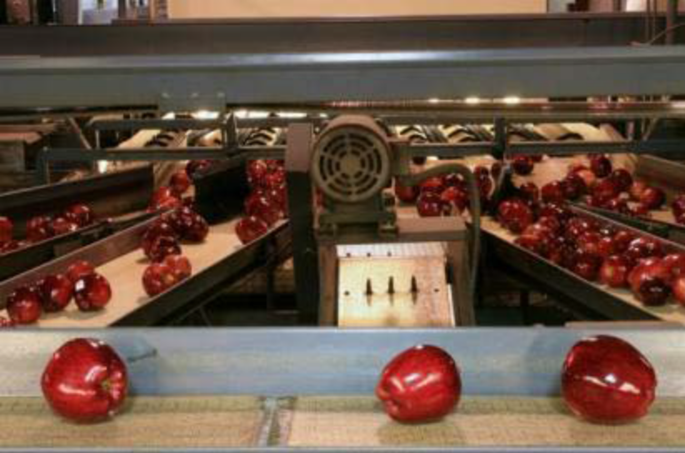

STORAGE

As a food safety manager, your attention should be focused on the production areas of the factory. However, product storage areas are equally as important since incorrect storage can pose a risk to the product and the factory itself.

The control of storage areas and product does not just include raw materials; it also involves the finished products, transportation, and waste storage.

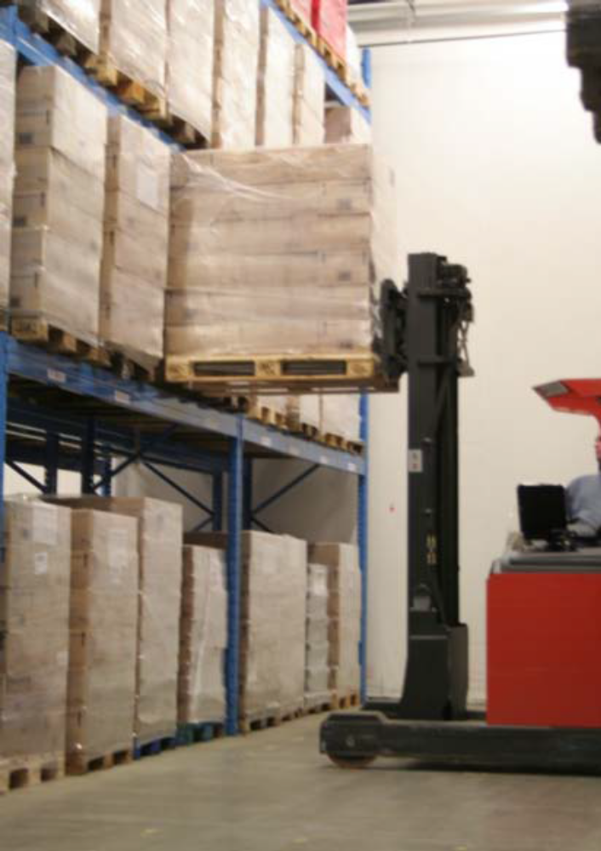

Storage of Raw Materials and Finished Products

The controls that exist for materials in the production area should be the same for raw materials. Raw materials and ingredients must be protected from contamination by physical, chemical, and microbiological contaminants, for they will have a significant effect on the finished product’s quality, safety, and legality. Your company will also experience significant commercial loss if raw materials are destroyed or if contamination of raw materials impacts the safety of semi-processed and finished products.

You must have raw material monitoring processes in place during receipt of products and their subsequent storage. If deterioration in quality or pest infestation is found immediate corrective actions should be taken.

Perishable raw materials and finished products should be stored under conditions, such as refrigeration or freezing, to prevent any potentially pathogenic bacteria from multiplying and to slow down the rate of spoilage. Storage methods must be conducive to following the “first in, first out” rule. Also, specific storage-related procedures should be in place and results recorded.

The finished food products should be stored in a suitable manner so that they cannot become contaminated or perish rapidly. If possible, finished products should also be stored away from raw materials since contact could lead to post-process contamination and, in some cases, pose a significant risk to health.

Transportation

A finished product can be compromised by inadequate handling procedures from factory storage areas to its transportation vehicle. It is good practice for there to be minimal distance between the finished product storage location and the transport vehicle loading dock. It is also good practice to have the transport vehicle pick up the product inside the facility to prevent outside atmospheric conditions from spoiling the product. The use of properly sealed loading docks is an example of effective practice in this regard.

Transportation vehicles, trailers and containers must not present a potential source of contamination for food products, and should be washed and sanitized as frequently as necessary to ensure potential food hazards are effectively controlled. You should be aware of the history of the vehicles, trailers and containers used to transport your food products, as some foodborne illness outbreaks have been caused by contamination resulting from prior loads.

Waste Storage, Removal, and Protection Against Pests

Waste within the facility should be stored in closed containers and segregated from processing areas. It is good practice to have a policy in place to identify waste as soon as possible and remove it from the production line to reduce the risk of contamination.

The waste that is being stored should be protected from pest infestation, which means keeping it in rodent-proof containers that are fully closed to prevent insect attraction.
The amount of waste being produced by the facility should be monitored since a build-up could mean an inadequate number of waste receptacles, resulting in waste being stored incorrectly.

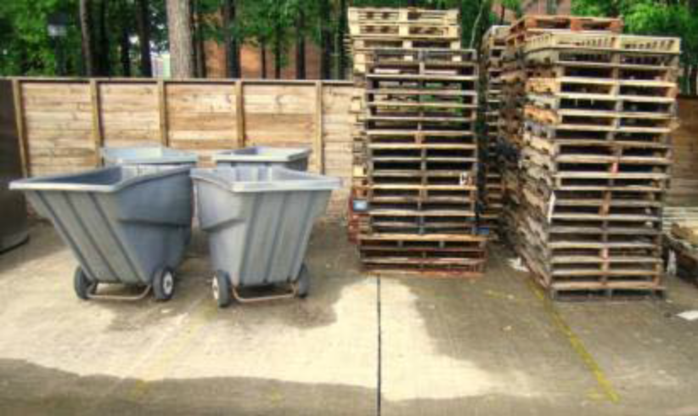

WINDOWS AND DOORS

Windows and doors are probably the most vulnerable part of the facility with respect to pests and other contaminants entering the factory. This section covers the measures that you can take to reduce the risk of pests and contaminants entering the facility, including proofing, screening, and a procedure for closing doors.

Proofing and Screening

Pest-proofing or screens should be used on all windows and doors in the facility. These screens should be easy to clean and cleaned regularly to prevent contamination. If there is an issue with dust coming into the facility, then dust screens should be added to all windows and doors.

Doors should not have significant gaps at the bottom since rodents can easily enter the facility. A rule used is that “if a pencil can fit under the door, then so can rodents.” Instead of replacing the door completely, pest excluders can be attached to the door, preventing pests from entering the facility.

Glass Contamination Prevention

Modern food facilities very rarely have glass windows as part of their design because of the risk of glass contamination in finished food products. If your facility has glass windows then make sure that there is adequate protection against breakage. You can do this by covering them with a screen or a clear plastic film so that if there is a breakage, no glass is deposited into the facility.

You should put in place a procedure that any broken glass is reported to you or supervisory staff immediately so that adequate steps can be taken to prevent contamination and guard the safety of staff and customers.

Door Closure Procedure

In any food production facility, it is bad practice to have doors open for long periods of time. Since factories are usually busy places and doors are used frequently, it is easy for staff to forget to close doors behind them. Wherever possible, external doors should be self-closing or on a timed switch where they close when not in use.

Doors fitted with curtains to prevent the ingression of flying insects or birds are not 100% effective, so doors should be fully closed when not in use.

LIGHTING

Adequate lighting with respect to the level of luminosity and light color is necessary to provide safe and satisfactory working conditions for staff and to allow essential activities such as cleaning and raw material inspection to take place under optimum conditions.
When reviewing the position of lighting in your facility, you should eliminate any possible contamination risk with respect to breakage. Fluorescent bulbs which can be easily damaged could break and contaminate product.

This section describes considerations for lighting and procedures to be taken to minimize the risk of glass contamination from lighting units in the facility.

Adequate Lighting

The intensity of lighting should be appropriate in relation to the activities undertaken within that area of the factory. Low levels of lighting can be a safety issue for staff and also allow pests such as rodents to remain undetected. Furthermore, inadequate lighting can hinder the effectiveness of cleaning and disinfection procedures.

Certain steps during production, such as the visual inspection of raw materials for possible contaminants, may require specific strategically-placed lighting units to ensure an optimum level of luminosity and color at all times of day. The use of natural or low-level lighting for such processes would mean that workers at night or workers with low levels of natural light would not achieve effective inspection or control of contamination.
The color of lighting is important, particularly when inspecting for color defects in products such as fruits and vegetables. The color of some light sources may prevent inspection staff from identifying product defects.

Lighting in Storage Areas

Lighting in storage areas is sometimes inadequate since these areas are often seen by factory management as being non-essential. Storage areas, however, must be regarded as high risk with respect to pest infestation and the monitoring of defective products (i.e. damaged packaging and product spoilage).

Pests, such as rodents, do not like well-lit areas, so it is good practice to have adequate levels of lighting in areas where rodents could be a risk. If you are storing raw materials which may be prone to insect infestation, you will need good lighting in the storage areas to monitor for any possible infestations.

In worse cases, inadequate lighting may impede the inspection or monitoring process and could lead to pest infestation throughout the factory.

Lighting Maintenance Procedures

Maintenance procedures should be in place for lighting units. It is important for maintenance staff to be aware of the risk of product contamination by glass if these procedures are not followed. To minimize any risk, maintenance on lighting units should occur only when there are no production activities taking place. It is good practice to document maintenance procedures and make staff aware of these procedures. It is also good practice to have procedures in place in the event of light units breaking, either when production is being carried out or during lighting maintenance.

All glass lighting units such as fluorescent bulbs should be protected by diffusers which will prevent breakage under normal use. These diffusers, however, should be regularly cleaned as part of the factory hygiene and cleaning schedule.

MONITORING OF FACILITIES

Monitoring is particularity important to ensure that the facility continuously meets requirements. Regular inspections are important and a schedule to do so should be in place. Problems unnoticed during daily production may go undetected and cause significant contamination issues.

A regular inspection should address things such as ventilation systems, overhead pipes, or external building fabrication that may not be noticed on a daily basis. If problems are found, the maintenance staff should be notified immediately and corrective actions taken as soon as possible. As always, monitoring procedures should be documented.

Section

2
Session 2 –
HACCP History, Legislation

GENERAL OVERVIEW

Implementing an effective food safety management system is critical to the production of safe food. Management systems based on Hazard Analysis and Critical Control Points (HACCP) are the international standard as recognized by the Codex Alimentarius Commission. HACCP systems build upon effectively designed and implemented prerequisite food safety programs, and focus on three key concepts: 1) identifying significant food safety hazards, 2) controlling these significant hazards, and 3) documenting the system.

This section focuses on requirements for implementing HACCP systems as described in the Codex Alimentarius General Principles of Food Hygiene. The following topics will be discussed:

- Introduction to HACCP

- Preliminary Steps

- Principle 1 – Conduct a Hazard Analysis

- Principle 2 – Identify Critical Control Points

- Principle 3 – Determine Critical Limits

- Principle 4 – Determine Monitoring Procedures

- Principle 5 – Determine Corrective Actions

- Principle 6 – Determine Verification Procedures/ Principle 7 – Record-Keeping Procedures
Introduction to HACCP

Section Overview

This section will introduce the participants to general concepts regarding the Hazard Analysis and Critical Control Point system for food safety management. HACCP systems are internationally recognized as the “Gold Standard” for risk-based management of food safety hazards.

The following topics will be discussed:

- Definition of HACCP

- Origins of HACCP

- Food safety hazards

- Prerequisite programs and HACCP

- HACCP plans

- HACCP plans – getting started

- The seven HACCP principles

Learning Objectives

At the conclusion of this section, the learner will be able to:

- define HACCP and list the five preliminary steps and seven principles that form the basis for HACCP systems,

- discuss the origins and history of HACCP systems,

- discuss the merits of process control versus end-product testing for management of food safety hazards,

- define a food safety hazard and list examples of biological, chemical and physical hazards,

- list common prerequisite programs and discuss their importance in overall food safety management, and describe HACCP plans and considerations in their development.

Definition of HACCP

HACCP (pronounced ‘HAS-sip’) stands for Hazard Analysis Critical Control Point. Hazard Analysis and Critical Control Points (HACCP) is “a systematic approach to the identification, evaluation, and control of food safety hazards.” Proper implementation of HACCP systems provides the framework to produce foods safely and to prove they were produced safely. It differs fundamentally from any inspection-based system because it identifies and deals with hazards before an incident occurs.

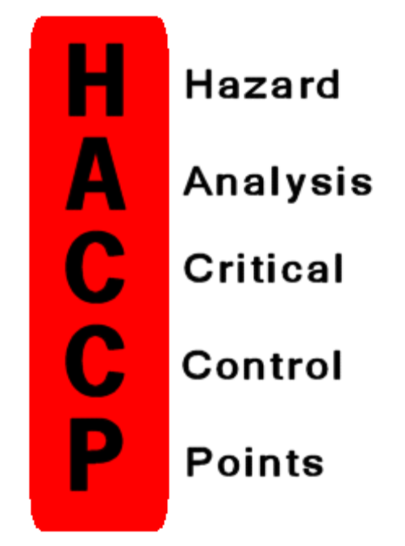

HACCP is:

- Recognized as the best way to eliminate, reduce or control hazards in a food handling or processing environment;

- Developed and maintained by individual processors to control their particular food safety environment; and

- Suitable for use in various food processing and handling facilities because the same HACCP principles apply whatever the location or food process.

HACCP is not:

  - A quality control program. Although HACCP principles can be adapted to deal with quality control issues, this program is not intended to address quality control;

  - A government controlled program. HACCP must be 100% (percent) owned and controlled by the processor;

  - Maintenance free. Unlike inspection programs and other food safety control methods, HACCP is not a snapshot effort to deal with production processes.

HACCP systems change continually and grow with a facility as it is developed and maintained; and

Consumer awareness of food safety and changing regulations are good reasons to adopt a food safety system such as HACCP.

  - A guarantee of food safety. Every step during the process from ‘farm-to-fork’ provides another opportunity for contamination of product. A well-designed HACCP system improves the chances that any hazards introduced in previous stages of the process will be detected.

HACCP first identifies potential food safety problems and then determines the best way to prevent, reduce or eliminate them.

All potential hazards are considered ahead of time. These are designed out of the production process. Safety is built-in.

Origins of HACCP

Food safety management systems, including HACCP, have evolved from total quality management systems developed by W.E. Deming in the 1950s. Deming emphasized a systems approach to manufacturing which managed all aspects of product quality.

HACCP food safety systems also trace their origins to work by the Pillsbury Company, United States Army, and the U.S. National Aeronautics and Space Administration (NASA) on food safety for manned space flights in the 1960s. Given the critical importance of food safety for the astronauts, a “zero defects” program was developed for space foods which emphasized process control as opposed to end-product testing. This emphasis on process control is a defining characteristic of modern HACCP systems.

HACCP was officially adopted as a recommended approach for food safety management by the Codex Alimentarius Commission in 1993. The document “Hazard Analysis and Critical Control Point (HACCP) System and Guidelines for its Application” was included as Annex A to the Codex General Principles of Food Hygiene in 1997.

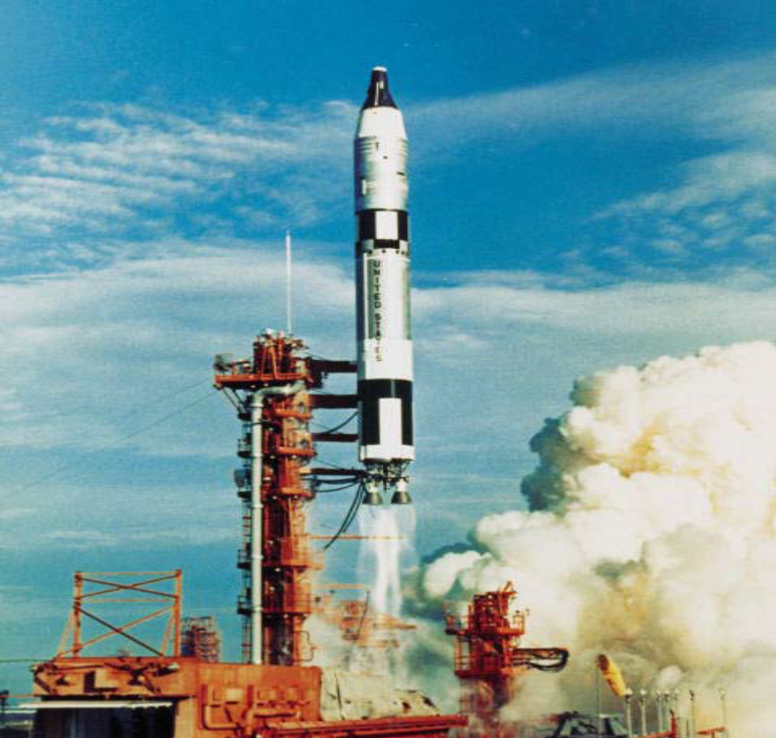
Food Safety Hazards

Hazards are defined as situations with the potential to cause an injury or illness in consumers. The four classes of hazards most commonly associated with food safety are:

  - Biological

  - Chemical

  - Physical

These hazards may exist in raw materials or be introduced at any stage during the manufacturing process.

A food safety hazard is defined by the Codex Alimentarius as “a biological, chemical or physical agent in, or condition of, food with the potential to cause an adverse health effect.”

Some sources of food safety hazards include but not limited to:

  - Facility environment

  - Improper handling

  - Unsanitary equipment

  - Poor employee practices

  - Raw materials or ingredients

Biological Hazards

A biological hazard is any danger to food safety caused by contamination with microorganisms. This type of hazard includes disease causing bacteria, viruses (e.g. Hepatitis A), parasites (e.g. Trichinella or Cryptosporidium), and moulds.

Chemical Hazards

Chemicals that can contaminate food products include:

  - Naturally occurring toxins (e.g. alkaloids in potatoes, toxic wild mushrooms or aflatoxin in peanuts);

  - Normally added ingredients (e.g. sodium nitrite can be toxic if added in high enough levels); and

  - Unintentionally added hazards (e.g. pesticides used to treat insect infestations or cleaning chemicals that may not have been safely rinsed from equipment).

Physical Hazards

Physical hazards are any foreign materials not normally found in food (e.g. rocks, broken glass, metal fragments or bone pieces).

Assessing Hazards

Some hazardous agents are more dangerous than others. There are significant differences in severity depending on the type of hazard and who is consuming it.

It is the processor’s responsibility to know the acceptable levels related of all types of standards. Some examples include the standard temperature that food can be safely stored or cooked to prevent the growth of microorganisms or the amount of normally added ingredients such as nitrates.

Some standards apply to the shelf life of ingredients, after which they are no longer safe to use in food. Each process will involve standards of handling and hygiene. It is the processor’s responsibility to know all standards and to ensure they are understood and used by employees.

Cross-contamination

Cross-contamination occurs when micro-organisms, allergens, foreign matter or chemicals are transferred unintentionally from one food or surface to another.
It is important that a HACCP plan clearly indicates the actual movement of employees. It must also indicate the flow of goods and process steps for each product. Because employees do not always follow formal processes, it is important to observe what actually happens in daily operations. This information is then analysed to identify situations where cross-contamination might occur.

Prerequisite Programs and HACCP

Before a HACCP system can be implemented, the company must be operating in accordance with good hygiene and good manufacturing practices. These prerequisite programs (PRPs), which are discussed elsewhere in this training provide the strong foundation which is necessary to ensure the food facility is capable of producing safe food. These PRPs must be in place before effective HACCP programs can be implemented. The importance of effective PRPs cannot be overstated, as they are the foundation of the HACCP plan. Inadequate PRPs may lead to additional critical control points that would have to be identified, monitored and maintained under the HACCP plan.

HACCP is a preventive system for ensuring food safety, but it is not a standalone system. To be effective, HACCP must be built upon current food safety programs such as Good Manufacturing Practices (GMPs) and Sanitation Standard Operating Procedures (SSOPs). These programs are known as “prerequisites” that provide a foundation for the HACCP program.

The following are examples of common prerequisite programs:

- Building and equipment design, fabrication and maintenance

- Production line design and product flow

- Cleaning and disinfection programs

- Equipment calibration

- Management commitment

- Supplier approval

- Product Specifications

- Water quality

- Staff hygiene practices

- Staff training

- Staff health

- Pest control

- Waste control

- Storage and Distribution

- Product recall

HACCP Plans

As stated previously, HACCP is “a systematic approach to the identification, evaluation, and control of food safety hazards.”

Key to the effective implementation is the written HACCP Plan, which is a document prepared in accordance with the principles of HACCP to ensure control of hazards that are significant for food safety in the segment of the food chain under consideration.

It is important to note that HACCP plans are specific to a food product and process. The plan is written by the HACCP team at the firm based upon the specific conditions in that facility. Any changes in product characteristics or processing steps will likely necessitate re-evaluation of the written HACCP plan.

The written HACCP plans at two facilities that are producing the same food product are likely to be different due to a variety of reasons including differences in types of equipment used, management of prerequisite programs, and other factors.

Section

3
Session 3 –
Steps for the Introduction of a HACCP system

General Overview

The preparation of an HACCP plan includes the following steps (according to FAO recommendations):

- The following topics will be discussed in this section:

- Assembling the HACCP Team

- Describing the Food and its Distribution

- Describing the Intended Use and Consumers of the Food

- Developing a Flow Diagram Which Describes the Process

- Verifying the Flow Diagram

HACCP – Getting Started

Design and implementation of effective HACCP systems requires systematic planning and execution.

The preliminary steps necessary before implementing a HACCP system include the following:

• Assemble the HACCP Team

• Describe the Food and its Distribution

• Describe the Intended Use and Consumers of the Food

• Develop a Flow Diagram Which Describes the Process

• Verify the Flow Diagram

These steps must be completed prior to beginning work on HACCP Principle 1. Preliminary steps will be discussed in the following section.

The Seven HACCP Principles

Following the effective completion of the HACCP preliminary steps, the team is ready to begin the process of writing the HACCP Plan. Writing the plan is a seven-step process which must occur in the following sequence.

1. Conduct a hazard analysis

2. Determine the CCPs

3. Establish critical limits

4. Establish monitoring procedures

5. Establish corrective actions

6. Establish verification procedures

7. Establish record keeping and documentation

In the following sections we will cover the basic concepts of each of these HACCP principles in sequence.

Assemble a multidisciplinary HACCP team

Assembling a HACCP team is an important step in building a HACCP plan. The team should consist of individuals with different specialties and experience with the process. The HACCP team should include members who are directly involved with the daily operations.

Involve people who will be responsible for developing or changing HACCP policies in their respective areas. They will have the best understanding of how changes will affect daily operations in that area. Involve employees and management who have varied skills and experience.

Make sure they can:

- Identify hazards;

- Determine critical control points (CCPs);

- Monitor CCPs;

- Verify operations at CCPs; and

- Examine samples and perform verification procedures.

Everybody on the team should have a basic understanding of:

- Technology and equipment used on the processing lines;

- Practical aspects of food operations;

- Flow and technology of processes;

- Applied aspects of food microbiology; and

- HACCP principles and techniques.

The size of the HACCP team will vary depending on the size and complexity of the food production process. At minimum, the HACCP team must consist of at least one person who is thoroughly familiar with all aspects of the facility and its products.

The team members should be knowledgeable about food safety hazards and HACCP principles. When issues arise that cannot be resolved internally, it may be necessary to enlist outside expertise.

In addition to writing and developing the HACCP plan, the HACCP team provides oversight of the implementation of the plan into the daily operations of the facility. This includes ensuring that applicable personnel are trained appropriately to handle their required duties.

Although one person may be able to analyze hazards and develop a HACCP plan successfully, many companies find it helpful to build a HACCP team. When only one person develops the HACCP plan, some key points can be missed or misunderstood in the process. The team approach minimizes the risk that key points will be missed or that aspects of the operation will be misunderstood. It also encourages ownership of the plan, builds company involvement and brings in different areas of expertise.

In small companies, the responsibility for writing the HACCP plan may fall to one person. If it is possible to build a HACCP team in a small company, employees knowledgeable of various divisions, including owners, should be members of the HACCP team.

Activity 1- Identify your HACCP Team

HACCP Team | Current Position | Role in  carrying out HACCP plan

Answer the following questions to complete the activity

- What are the skills of the different members of your team?

- Who will carry out the HACCP plan on an ongoing basis?

- Who will oversee the HACCP process?

- Can you justify why each person on your team is qualified to carry out his or her role?

- How will each person on the HACCP team secure adequate time to dedicate to the HACCP plan?

Management Commitment

Management commitment is key to a successful food safety system. Commitment ensures that a food safety system is as much a part of daily business as maintaining sales and reducing costs.

Even if management only plays a supporting role in the food safety system, management commitment must be visible to all employees.

Management commitment can be shown by:

- Promoting HACCP activities at internal meetings;

- Posting signs indicating in-house HACCP policies;

- Posting a sign indicating management commitment to HACCP;

- Supplying adequate resources for HACCP development, implementation and food safety training;

- Regular review of HACCP materials and progress reports;

- Regular attendance by management at HACCP training sessions;

- Standardizing and enforcing disciplinary actions for employees who don’t meet their HACCP responsibilities.

Description of products, their methods of production and distribution

In the next step the HACCP team describes the product and its method of production and distribution, as well as intended use and consumers.

The following questions should be answered during the description phase:

1. What is the common name of the product?

2. How is the product to be used?

3. What type of packaging is used for the product?

4. What is the shelf life of the product and at what temperature?

5. Where will the product be sold? Who is the intended consumer and what is the intended use?

6. What labelling instructions are needed?

7. Is special distribution control needed?

Activity 2: Product description

Worksheet 2: Product description

Process category:

Product:
- Common name
- How is it to be used?
- Type of package
- Shelf life and at what temperature
- Where will it be sold?
Consumers
Intended use
- Labelling instructions
- Is special distribution control needed?

Develop and Verify a Process Flow Chart

A flow chart provides an important visual tool that the HACCP team can use to identify and describe the process. When developing a process flow chart, it is important to include all the process steps within the facility’s control from receiving through final product storage, including reworked product if applicable. Since the accuracy of the process flow is critical to conduct a hazard analysis, the steps outlined in the chart must be verified in the facility.

If a step is missed, a significant food safety hazard may be missed. Include every handling, processing and holding step for primary product as well as ingredients and packaging. The HACCP team should walk through the facility and make any changes required in the flow chart. The walk-through allows each team member to gain an overall picture of how the product is made. It may be helpful to invite additional facility personnel to review the diagram during the walk-through.

Verifying the flow chart

To complete this step, the HACCP team must look at those processes identified and documented in the flow chart, and confirm them through physical observation. This means onsite confirmation that the assumptions are correct and steps are being carried out as the graphic implies. Although the HACCP team should already be familiar with the processing steps, it is important for the team to observe the operations long enough to be confident that their flow diagram lists all processing steps in chronological order.

Your team should:

- Observe employees executing each processing step.
- Observe hygienic practices while noting all potential hazards.
- Observe and analyze process steps that destroy microorganisms.

Describe the Process

A written process description can be a useful tool to explain what happens at each of the process steps needed to produce a product covered by a particular HACCP plan. This description can be used as a working reference for the development of the HACCP plan and to facilitate communication with company personnel and regulators. It is also important to know what occurs at each process step. For example, it is important to know information about process steps such as the maximum length of time that the product could be exposed to unrefrigerated temperatures, the maximum room air temperature, or the maximum internal product temperature. This information is necessary to conduct an accurate hazard analysis.
Activity 3: Develop a Process Flow Chart related to your products

Worksheet 3: Process Flow Chart
Task 1 | Title:
Task 1 | Description:

Task 2 | Title:
Task 2 | Description:
Task 3 | Title:
Task 3 | Description:
Task 4 | Title:
Task 4 | Description:
Task 5 | Title:
Task 5 | Description:
Task 6 | Title:
Task 6 | Description:
Task 7 | Title:
Task 7 | Description:

Section

4
Session 4 – Identifying hazards and their control

GENERAL OVERVIEW

This section will cover the first principle of HACCP -conducting a hazard analysis. Conducting a complete and accurate hazard analysis is the most important step in developing a valid HACCP plan, so the HACCP team must approach this step in a systematic, thorough manner.

In this section you will learn how to:

• Conduct a hazard analysis

• Identify significant hazards

• Identify control measures

HACCP PRINCIPLE 1:

HAZARD ANALYSIS

The first step in developing a HACCP plan is to identify all of the significant food safety hazards that are associated with the seafood product(s) and process (es), as well as the control measures. This procedure is called hazard analysis, the first principle of HACCP

A hazard is defined as any biological, chemical or physical agent that is reasonably likely to cause illness or injury in the absence of control(s). The term hazard, when used in the context of HACCP, is limited to food safety concerns that could cause consumer illness or injury.

Not all potential hazards are significant. A significant hazard is one that is reasonably likely to occur and presents a health risk to the consumer if it is not controlled. Control measures must be identified for all significant hazards.

The hazard analysis is conducted to identify:

• All potential food safety hazards,

• Which of these hazards are significant, and

• Measures to control the significant hazards.

How to Conduct a Hazard Analysis

There is a sequence of steps that need to be completed when conducting a hazard analysis. Each step is an important part of the procedure. These steps will be discussed individually using a worksheet to document the results or conclusions.

There are five steps in a hazard analysis:

1) List process steps

2) Identify potential food safety hazards

3) Determine if the hazard is significant

4) Justify the decision

5) Identify control measure(s)

Activity 4: Conduct a Hazard Analysis

Worksheet 4: Conduct a Hazard Analysis using a worksheet provided

NOTE:

The worksheet is used to:

• List each of the process steps from the process flow chart (Column 1). Refer to Activity 3: Develop a Process Flow Chart related to your products

• List all potential related hazards that are identified during the hazard identification step (Column 2).

• Record the result of the hazard evaluation. A “Yes” or “No” answer to the question: “Is the potential food safety hazard significant?” is entered in this column (Column 3).

• Explain why the hazard is significant or not (Column 4).

• List control measures for those hazards that have been identified as significant and need to be controlled at a specific operational step (Column 5).

Hazard Analysis Worksheet

(1) (2) (3) (4) (5) (6)
Ingredient/  processing  step | Identify potential hazard(s) introduced, controlled, or enhanced at this step | Are any potential food safety hazards significant?  (Yes/No) | Justify your decision for Column # 3 | What preventative measure(s) can be applied for the significant hazards? | Is this step a Critical Control Point?  (Yes/No)
 | Biological
 | Chemical
 | Physical
 | Biological
 | Chemical
 | Physical
 | Biological
 | Chemical
 | Physical
 | Biological
 | Chemical
 | Physical

(1) (2) (3) (4) (5) (6)
Ingredient/  processing  step | Identify potential hazard(s) introduced, controlled, or enhanced at this step | Are any potential food safety hazards significant?  (Yes/No) | Justify your decision for Column # 3 | What preventative measure(s) can be applied for the significant hazards? | Is this step a Critical Control Point?  (Yes/No)
 | Biological
 | Chemical
 | Physical
 | Biological
 | Chemical
 | Physical
 | Biological
 | Chemical
 | Physical
 | Biological
 | Chemical
 | Physical
 | Biological
 | Chemical
 | Physical

Hazard Evaluation and Justification (Column 3)

After the hazard identification (step 2) is completed, the HACCP team must evaluate the hazards. Each potential hazard will be evaluated to determine if it is significant at each process step. The hazard evaluation, or risk assessment, is designed to determine which hazards are reasonably likely to occur and need to be controlled.

HACCP focuses solely on food safety hazards that are reasonably likely to occur and are likely to result in an unacceptable health risk to consumers if they are not controlled. The hazard evaluation is designed to determine which hazards are relevant.

To determine if a hazard is significant, consider two questions:

1) Is the hazard reasonably likely to occur in the finished product in the absence of control?

2) Is the hazard likely to cause consumer illness?

Identifying Control Measures (column 5)

The final step in the hazard analysis process is to determine the appropriate control measures you intend to use to prevent, eliminate or reduce to an acceptable level each of the significant hazards identified in your hazard evaluation. This is important because if the hazard is truly significant there must be an appropriate control measure or your product would not be safe.

Control measures are actions and activities that can be used to prevent, eliminate, or reduce a food safety hazard to an acceptable level. In practice, control measures could include a wide array of activities that will be effective for a specific hazard.

Control measures can be used to:

• Prevent a food safety hazard,

• Eliminate a food safety hazard, or

• Reduce a food safety hazard to an acceptable level.

Section

5
Session 5 –
Critical limits, monitoring, corrective action and records

General Overview

This section will cover the following HACCP principles

- Principle 2: Determine Control Point (CCP)

- Principle 3: Establish Critical Limits

- Principle 4: Critical Control Point Monitoring

- Principle 5: Corrective Actions

In this section you will learn:

  - The definition of a Critical Control Point (CCP).

  - The relationship between significant hazards, control measures, and CCPs.

  - How CCPs may be different for different products and processes.

  - Tools to help you determine which steps are CCPs.

  - Examples of CCPs for various food safety hazards.

  - Types of monitoring

  - Monitoring procedures/ Staff responsible for monitoring/ Monitoring records/ Corrective Actions

HACCP PRINCIPLE 2:

DETERMINE CRITICAL CONTROL POINT

HACCP Principle No. 2 states:

"Identify the Critical Control Points (CCPs) in the process."



The determination of critical control points is the second principle of HACCP. The Codex guidelines define a critical control point (CCP) as "a step at which control can be applied and is essential to prevent or eliminate a food safety hazard or reduce it to an acceptable level".

If a hazard has been identified at a step where control is necessary for safety/and if no control measure exists at that step or at any other, then the product or process should be modified at that step, or at an earlier or later stage, to include a control measure.

The determination of a CCP in the HACCP system can be facilitated by the application of a decision tree such as that included in the Codex Hazard Analysis and Critical Control Point (HACCP) system and guidelines for its application (see Figure) which indicates a logical reasoning approach. The application of the decision tree should be flexible according to the type of operation (production, slaughter, processing, storage, distribution or other). The decision tree proposed by Codex may not be applicable to all situations. Other approaches based on risk analysis may be used

How to identify Critical control points

Critical control point decision tree

One strategy to facilitate the identification of each CCP is the use of a CCP decision tree. Although application of the CCP decision tree can be useful in determining if a particular step is a CCP for a previously identified hazard, it is merely a tool and not a mandatory element of HACCP. A CCP decision tree is not a substitute for expert knowledge.

Applying a CCP decision tree involves asking a series of questions to determine whether a process step is a CCP.

Important considerations when using the decision tree:

• The decision tree is used after the hazard analysis.
• The decision tree is used at the point where a hazard that must be addressed in the HACCP plan has been identified.

• A subsequent step in the process may be more effective for controlling a hazard and may be the preferred CCP.

• More than one step in a process may be involved in controlling a hazard.

• More than one hazard may be controlled by a specific control measure.

Figure 1: Decision tree to identify critical control points (source: Hazard Analysis and Critical Control Point (HACCP) system and guidelines for its application)

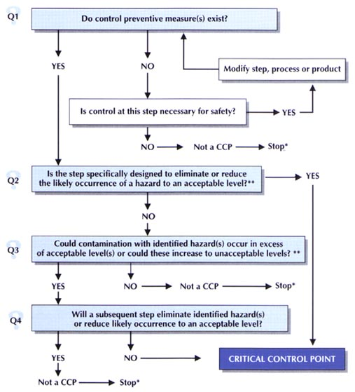

The CCP decision tree questions

Question 1: Do control measure(s) exist?

Question 1 should be interpreted as asking whether or not the operator could use a control measure at this operation or anywhere else in the food establishment to control the identified hazard. Control measures could include, for example, temperature control, visual examination or use of a metal detector.

If the response to Question 1 is "yes", in the Question 1 column on Form 8 clearly describe the control measure(s) that the operator could use and proceed to Question 2 in the decision tree.

If the response is "no", i.e. a control measure does not exist, indicate how the identified hazard will be controlled before or after the manufacturing process (outside the control of the operator). For example, salmonella in raw poultry is controlled by the end-user. Alternatively, modify the operation, process or product so that a control measure exists, and then proceed to the next identified hazard in the process.

Example of decision tree to identify critical control points

Question 2: Is the step specifically designed to eliminate or reduce the likely occurrence of the identified hazard to an acceptable level?

Examples of procedures or operations in a food process that are designed specifically to identified hazard include:

· The retorting operation in a canning plant
· Pasteurization
· Chlorination of cooling water
· The addition of a metal detector to a process line
· A particular sanitation procedure performed by the operator to clean contact surfaces without which the line would be stopped and the product would be contaminated
Acceptable and unacceptable levels need to be defined within the overall objectives in identifying the CCPs of the HACCP plan.

If the process or operation is specifically designed to eliminate or reduce the likely occurrence of the hazard to an acceptable level, answer "yes" under Question 2 on Form 8; such a step automatically becomes a CCP and it should be identified as such in the last column of Form 8.

If the step is not specifically designed, answer "no" and proceed to the next question. Note that Question 2 applies to processing operations only. For incoming materials as delivered, write "no" and proceed to Question 3.

Question 3: Could contamination with the identified hazard occur in excess of acceptable levels or increase to unacceptable levels?

In other words, is it likely that the hazard could have an impact on the safety of the product? Question 3 refers to both probability (likelihood) and seriousness. The response is a judgement call involving risk assessment which must be based on all of the information that has been gathered. When answering "yes" or "no", it may be useful to explain in the Question 3 column the basis of the response, for future reference. This would be especially useful in dealing with some hazards that may be controversial.

If searches in the company's complaint files or scientific literature suggest that contamination with the identified hazard may increase to an unacceptable level and result in an unacceptable health hazard, answer "yes" and proceed to the next question in the decision tree.

If the contamination is not known to represent a substantial threat to human health or is not likely to occur, answer "no" (not a CCP) and proceed to the next identified hazard in the process.

Question 4: Will a subsequent step eliminate the identified hazard or reduce likely occurrence to an acceptable level?

This question is designed to identify those hazards that are known to represent a human health threat or that could increase to an unacceptable level, and that will be controlled by a subsequent process operation.

If no subsequent operation is scheduled in the process to control this identified hazard, answer "no". This particular process step becomes a CCP and should be identified as such in the last column of Form 8.

If there is a subsequent operation or operations later in the process that will eliminate the identified hazard or reduce it to an acceptable level, answer "yes". This step is not a CCP. However, you will need to identify the subsequent step(s) that control(s) the hazard, thus proceeding to the next identified hazard.

Source: http://www.fao.org/3/w8088e/w8088e05.htm#module%207%20%20%20determine%20critical%20control%20points%20%20%20task%207principle%202

Critical Control Point Placement

If there are no control measures that can be applied at a particular process step, that step cannot be the CCP. In some cases control measures should be applied at a particular step, but that step may not be the best place to control the hazard. In that case, a processing step that occurs later in the process flow may be the best place to control that hazard.

For example, when producing a cooked product, the hazard of pathogen growth would first be identified at the receiving step. This hazard could be controlled at any process step where the hazard can be adequately controlled. However, the best place to control this hazard would be the cooking step, where the hazard is eliminated. The cook step would be the CCP for this hazard.

There may be different control options for a single hazard. For example, a metal hazard can be controlled at different processing steps such as:

• At receiving, ingredients are sourced that are free of metal fragments,

• At a screening step, screens are used to remove any metal fragments,

• At a metal detection step, a detector is used to find any finished products that are contaminated with metal fragments.

Only one of these processing steps would likely be the best CCP to control this hazard.

Examples of Critical Control Points

A CCP is a step where a hazard can be prevented, eliminated or reduced to an acceptable level.

Examples of CCPs where a hazard can be prevented are;

• Chemical hazards caused by excessive application of a certain food additive can be prevented at the step where the ingredient is added.

• Histamine formation in certain fish species can be prevented at all steps where the proper use of ice, refrigeration, or managing the time out of refrigeration can prevent the Product from being exposed to a temperature above 40°F for an extended period of time.

• Chemical hazards such as drug residues in aquaculture products can be prevented at the receiving step by using controls such as supplier declarations or testing.

HACCP PRINCIPLE 3:

ESTABLISH CRITICAL LIMITS

A critical limit represents the boundaries that are used to ensure that a hazard has been controlled (prevented, eliminated, or reduced to an acceptable level) at each CCP. Critical limits must be based on what science or industry experience has demonstrated is necessary to control the hazard.

A Critical Limit is defined by the Codex Alimentarius Commission as “a criterion which separates acceptability from unacceptability.”

The U.S. National Advisory Committee on Microbiological Criteria for Foods (NACMCF) has a more precise definition of a Critical Limit. The NACMCF definition is “a maximum and/or minimum value to which a biological, chemical or physical parameter must be controlled at a CCP to prevent, eliminate or reduce to an acceptable level the occurrence of a food safety hazard.”

There are many different types of critical limits. They must be specific for the critical control point and the hazard that is being controlled. Different critical limits may be needed for the related hazards.

An effective critical limit will define what can be measured or observed to demonstrate that the hazard is being controlled at that CCP. For example, both time and temperature are necessary elements of a critical limit to eliminate food safety hazards like pathogens at a cook step.

Critical Limits are established only at Critical Control Points

Deviations

In HACCP, a deviation refers to “a failure to meet a critical limit.” You also often see these events referred to as nonconformities.

Not meeting a critical limit could indicate:

•evidence that a direct health hazard already exists (e.g. bacterial contamination of a ready-to-eat food), or
•evidence that a direct health hazard could develop (e.g. under-processing of a low-acid food), or
•that a product was not produced under conditions assuring safety (e.g. metal detector calibrated incorrectly)

Establishing Critical Limits

Critical limits are defined based upon their ability to control (prevent, eliminate, or reduce to an acceptable level) the significant hazard(s) identified at a Critical Control Point.

The following list provides possible bases for selecting Critical Limits.

Biological hazards

- Conditions necessary for inactivation of microorganisms, prevention of toxin formation, destruction of preformed toxins, prevention of growth of microorganisms.

Chemical hazards

- Formulation and operating conditions necessary to control concentrations of chemical hazards below established safety limits. These safety limits for chemical hazards (such as regulatory Maximum Residue Levels) are often defined by toxicology studies in animal models or other methodologies.

Physical hazards

- Criteria on foreign materials can be related to potential for causing injury (e.g. object size, hardness, sharpness).

Operating Limits

An Operating Limit is defined as “a criterion that is more stringent than a critical limit and that is used by an operator to reduce the risk of deviation.”
Operating limits are parameters that exceed those necessary for safety and are established for reasons other than food safety.

For example, operating limits may be used to compensate for expected variation in operation of processing and monitoring equipment so that critical limits are not violated.

Documenting Critical Limits

The critical limits determined by the HACCP team as well as the rationale for their selection must be documented and maintained as HACCP records. Remember that a critical limit is a maximum and/or minimum value, not an average value. Critical limits based on subjective data (e.g. visual inspection) must be supported by instructions or specifications and/or education and training.

Below is an example of the critical limits that might be established for a CCP in the cooking of a ground beef patty. Note that, in this case, temperature and time are not sufficient to define the process because the time required to reach an internal temperature which destroys bacterial pathogens depends upon the dimensions (i.e. thickness) of the beef patties. As this is a moist cooking process, oven humidity is also a consideration. This example illustrates to potential complexity associated with defining critical limits which will effectively control a hazard at a CCP.

HACCP RINCIPLE 4:

DETERMINE MONITORING PROCEDURES

The fourth principle of HACCP is to establish CCP monitoring requirements and procedures for using the results of monitoring to adjust the process and maintain control. Properly designed and implemented CCP monitoring procedures are essential to demonstrating that the process is under control and establishes records to document compliance with the HACCP plan.

Definitions and Preliminary Considerations

Monitoring is defined as “The act of conducting a planned sequence of observations or measurements of control parameters to assess whether a CCP is under control.”

In a HACCP system, monitoring procedures must be designed to accomplish the following objectives.

1. Track the operation of the process and enable the identification of trends toward a loss of process control that would necessitate process adjustments.

2. Identify when there is a loss of process control and a deviation occurs at a CCP.

3. Provide written documentation of the process control system.

Types of Monitoring

There are many different types of monitoring procedures. Monitoring can be based on:

1. Quantitative measurements (e.g. such as measurement of temperature, time, pH, water activity, etc.), or

2. Observation by a trained individual (e.g. manual sorting)

Monitoring procedures also can either be continuous or discontinuous. Discontinuous monitoring is also commonly referred to as batch or attribute sampling.

Monitoring Procedures

A well-designed monitoring procedure will address each of the following points.

1. Who is responsible for the monitoring activity (usually by position or job title, not name of an individual)

2. What is to be monitored?

3. How it is to be monitored?

4. When monitoring will take place, and how often (frequency)

A monitoring procedure that meets each of these requirements and is appropriately implemented will enable the establishment to document that critical limits in the process are being met.

Monitoring Records

Monitoring procedures performed during the operation should result in written documentation which will serve as an accurate record of the operating conditions.

These records must include the:

•actual monitoring information,

•date and time the activity took place, and

•the signature or initials of person conducting the monitoring procedure.

Accurate monitoring procedures and associated records allow the operator to make decisions on the acceptability of the lot. To complete the monitoring process, data derived from monitoring should be reviewed and evaluated by a designated person (or persons) with knowledge and authority to carry out corrective actions when indicated.

HACCP PRINCIPLE 5: DETERMINE CORRECTIVE ACTIONS

The fifth principle of HACCP is to establish corrective actions to be taken when monitoring indicates that there is a deviation from an established critical limit. Taking appropriate corrective actions in the event of a deviation at a critical control point is essential to producing safe food. If corrective actions are not properly conducted, potentially unsafe food could leave your establishment and cause illness in consumers of your food products.

The Codex guidelines for application of the HACCP system define deviation as "failure to meet a critical limit". Procedures should be put in place to identify, isolate and evaluate products whose critical limits are exceeded.

As deviations from critical limits will occur, the company needs to have a plan to make sure these deviations do not result in unsafe products. The manufacturer's corrective action programme should include the following:

• Investigation to determine the cause of the deviation;

• Effective measures to prevent recurrence of the deviation;

• Verification of the effectiveness of the corrective action taken.

The HACCP team needs to devise a standardized set of actions that company employees will follow when there is a deviation from a critical limit. The following questions will help in developing effective corrective actions (source: American Meat Institute foundation):

  - How will people be informed when the deviation occurs? If a person is performing the monitoring procedure, who will that person contact?

  - Who will be responsible for controlling the product that may have been affected by the deviation? How should that person decide how much product needs to be controlled?
  - Who will be involved in deciding what to do about the product which might have been affected by the deviation?

  - Once it has been figured out what was the cause of the deviation, who will be involved in deciding how to get the process back in control and prevent recurrence of the deviation?
  - Who will be responsible for keeping the records of everything the company does in response to a deviation from a critical limit at this CCP?
  - If any person who has a responsibility in the corrective action plan is not available, who will be the back-up?

Specific corrective actions must be developed for possible deviations at each CCP in the HACCP plan for a product.

To the extent possible, corrective actions should be pre-planned. However, it is not possible to pre-plan for all corrective actions. You need to have a process in place to control nonconforming product and evaluate it to determine its ultimate disposition.

As a minimum, the HACCP plan should specify:

•what is done when a deviation occurs,

•who is responsible for implementing the corrective actions, and

•what records will be developed and maintained of the actions taken.

Individuals who have a thorough understanding of the process, product and HACCP plan should be assigned the responsibility for oversight of corrective actions. As appropriate, experts may be consulted to review the information available and to assist in determining disposition of non-compliant product.

Determining and Correcting the Cause of Non-compliance

The first corrective action to be taken in the event of a deviation at a CCP should be to bring the process back under control.

This corrective action may simply require a process adjustment to bring the process back into compliance with the established critical limits. For example, if monitoring of a cooking process indicates that the product has not achieved an appropriate internal temperature, an appropriate corrective action might be to increase the cooking time and/or temperature until the appropriate internal temperature is met.

In some cases, it may not be possible to immediately bring the process back under control. In these instances, an appropriate corrective action may be to stop the processing line and hold all affected product (and products in process) until the cause of the non-conformity can be assessed and corrected.

Corrective actions may require root cause analysis to determine the cause of the non-conformity and provide assurance that continued deviations do not occur.

Identifying Affected Product and Determining its Disposition

The second important task a corrective action must accomplish is to identify product affected by the deviation and determine its final disposition.

With regard to identification and isolation of the affected product, the following steps must be accomplished:

1. All affected product (i.e. that processed since the last point at which the CCP was known to be under control) must be isolated.

2. Isolated product must be clearly marked (e.g. with firmly attached tags) with information including: hold number, product, amount, date held, the reason for the hold, and the name of the person holding the product.

3. The producer must maintain control of the product from the hold date to the date of final disposition.

Furthermore, the product must be held under conditions that minimize its further deterioration (e.g. refrigeration or freezing where necessary).
If products that have left control of the organization are subsequently determined to be unsafe, the organization must initiate a withdrawal.

After the affected product has been identified and isolated, the establishment must evaluate these products to determine their final disposition.

Product evaluation should be conducted by a qualified person. For example, thermal process deviations should be evaluated by a competent process authority or someone having similar expertise.

The evaluation of affected product should be adequate to detect potential hazards. It should be ensured that sampling is adequate to identify the extent of the problem, that the tests are appropriate, that the judgment is based on sound science, and that the product is not released until the evaluation has determined that no potential hazard exists.

Each lot of nonconforming product can only be released as safe when any of the following apply:

• Other evidence demonstrates that the control measures have been effective.

• Evidence shows that the combined effect of the control measures for that particular product complies with the performance intended.

• Sampling, analysis and/or other verification activities demonstrate that the affected product complies with the identified acceptable levels for the food safety hazard(s) concerned.

Following evaluation, there are several possible fates for the product affected by the non-conformity. The product could be:

1. Determined to be safe for the intended use,

2. Determined to be safe for some other use,

3. Reprocessed in a manner to ensure it becomes safe,

4. Used for purposes other than originally intended, or

5. Destroyed and/or disposed as waste.

Recording Corrective Actions

Records for corrective actions and nonconformities must include the following information:

-The actual production records for the product

A standard form listing the following:

-Hold number, deviation, reason for hold, date and code of product held, quantity of product held, name and signature of responsible individual
–Results of product evaluation: Authority recommendations, product testing results, decision on final disposition of product in question
–Accurate accounting of all units in question
–Statement of the procedure for handling the nonconformity
–Cause of deviation identified
–Corrective action taken to prevent recurrence of deviation

Section

6
Session 6 – Implementation and Maintaining HACCP, Reviews and Validation

GENERAL OVERVIEW

This section will cover the following HACCP principles and discuss how HACCP is maintained.

• Principle 6: Establish Verification Procedures

• Principle 7: Record-Keeping Procedures

The following topics will be discussed in this section:

- Definitions and preliminary considerations

- Validation

- Verification

- Recording verification activities

- Types of HACCP records

- Control of documents

- Retention of records

- Electronic records

- Review of records

- Records – other considerations

- HACCP plan form

- Final considerations on HACCP systems

HACCP PRINCIPLE 6:

VERIFICATION PROCEDURES

The sixth principle of HACCP is to establish HACCP plan verification procedures. Verification procedures for HACCP plans are critical because these activities demonstrate that the written HACCP plan is able to control the appropriate hazards in the product, and that the HACCP plan is being implemented as written.

Definitions and Preliminary Considerations

The Codex guidelines define verification as “the application of methods, procedures, tests and other evaluations, in addition to monitoring to determine compliance with the HACCP plan.”

Verification includes the procedures that are needed to ensure that the HACCP plan is designed properly and has been implemented correctly. The validity of the HACCP plan is determined before the plan is implemented.

A key concept in the verification principle is “Trust what you can verify”

Routine verification is used to determine if the plan is working properly.

Validation essentially is the part of HACCP plan verification that asks the question “Am I doing the right thing?”

Validation involves a scientific and technical review of the rationale behind each part of the HACCP plan from hazard analysis through each CCP verification strategy. This is conducted by the HACCP team, with assistance by additional experts as necessary.

Initial Validation

Initial validation is conducted within the first weeks or months of implementation of the HACCP plan. During initial validation, the team should aim to achieve the following:

• assure that the plan is valid for controlling food safety hazards associated with the ingredients, process, and product, and

• verify that the plan can be implemented as written.

HACCP plan validation should include:

• A review of the hazard analysis,

• CCP determination,

• Justification for critical limits, based for example on current good science and regulatory requirements, and

• Determination of whether monitoring activities, corrective actions, record keeping procedures and verification activities are appropriate and adequate.

If deficiencies are noted in any of these areas, the HACCP team must revise the HACCP plan. These changes must be implemented as rapidly as is practicable

Revalidation

Revalidation, or reassessment, also is a required element of the HACCP system.

It is necessary:

• After any changes are made that could affect the hazard analysis or the HACCP plan,

• When any changes are made to the HACCP system, and

• When specifically required by regulatory authorities or private standards bodies

Revalidation of the HACCP plan may also be necessary when:

• New information arises concerning the safety of a product or ingredient,

• The product or product category is linked to a foodborne disease outbreak,

• The regulatory agency issues alerts related to the product or process,

• Multiple deviations from a Critical Limit occur,

• Inadequate record-keeping is followed,

• Recalls or product withdrawals occur, or

• Consumer complaints occur.
When the reassessment is complete, the HACCP team should issue a report detailing their findings. This report must be maintained as a HACCP record.

The HACCP plan must be modified immediately if reassessment indicates the HACCP plan is no longer adequate.

Verification Activities

Verification of Prerequisite Programs:

Verification of general prerequisite programs such as issues relating to the premises should include a periodic review of written procedures to ensure the programs are operating as planned.

Elements of prerequisite programs that are incorporated into the HACCP plan (e.g. calibration of monitoring devices) should be included as a verification procedure.

Verification of Critical Control Points:

Primary verification activities for CCPs should include:

• Calibration of processing and monitoring instruments,

• Review of calibration records,

• Review of monitoring records and corrective action reports,

• Independent check on the adequacy of the CCP to control the identified hazard, if possible, and

• Targeted sampling and testing.

Calibrations should be performed on equipment and instruments used in monitoring or verification at a pre-determined frequency sufficient to ensure accuracy of measurements. Calibrations should be conducted by checking the accuracy of each measuring device against a recognized standard at or near the condition that the instrument or equipment will be used.

Verification of the HACCP Plan:

Verification of the HACCP plan should focus on ensuring that the implementation of the HACCP plan complies with the written HACCP plan. The goal at this stage is to check for compliance with the written HACCP plan, not its validity (the latter is conducted during HACCP plan validation).

HACCP plan verification activities can include an on-site audit and review of HACCP records. This verification should focus on confirming that:

• The product description and flow diagram are accurate,

• Critical control points are monitored as required by the HACCP plan,

•processes are operating within established critical limits,

•Records are completed accurately, at the time intervals required, and reviewed appropriately,

•Consumer complaints are reviewed and appropriate action taken,

•Monitoring activities have been performed at the locations specified in the HACCP plan,

•Monitoring activities have been performed at the frequencies specified in the HACCP plan,

•Corrective actions have been performed whenever monitoring indicated deviation from critical limits, and

•Equipment has been calibrated at the frequencies specified in the HACCP plan.

Recording Verification Activities

Verification activities for the HACCP system must be documented. Examples of verification records include the following:

• Records documenting the accuracy and completeness of the written HACCP plan

• Records demonstrating that the written HACCP plan is being effectively implemented

• Results of verification audits conducted by the HACCP team and by external agencies

• Reports summarizing HACCP plan reassessment activities

• Equipment testing and evaluation

• Calibration records for monitoring equipment

HACCP PRINCIPLE 7:

RECORD- KEEPING PROCEDURES

The seventh and final principle of HACCP is to establish effective record-keeping procedures that document the HACCP system. Maintaining complete and accurate records is essential to ensure effective monitoring of the HACCP system and demonstration of compliance with food safety requirements.

Preliminary Considerations

Efficient and accurate record keeping is essential to the application of a HACCP system. According to the Codex guidelines, “documentation and record keeping should be appropriate to the nature and size of the operation and sufficient to assist the business to verify that the HACCP controls are in place and being maintained.”

Although it requires considerable effort, the record-keeping program should be viewed as a benefit rather than a burden for the following reasons.

• Records are the only references available to trace the production history of a finished product.

• Records can be used as a tool to alert the operator to potential problems before they lead to the violation of a critical limit.

• Records can serve as evidence that proper procedures are being followed.

Effective records help to document the measures of the HACCP plan and the effectiveness of the system.
The best record keeping system is usually the simplest one that can be easily integrated into the existing operation. One way to approach development of the record keeping requirements of the HACCP system is to review the records the company already keeps and see if they are suitable, in their present form or with minor modifications, to serve the purposes of the HACCP system.

The following list shows the records a company will have to develop (source: FAO, Food quality and safety systems training manual):

RECORDS GENERATED BY THE HACCP SYSTEM

Monitoring records for all Critical control points:

All HACCP monitoring records should be kept on forms that include the following information:

• Form title;
• Time and date;
• Product identification (including product type, package size, processing line and product code);
• Critical limits;
• Monitoring observation or measurement;
• Operator's signature or initials;
• Corrective action taken, where applicable;
• Reviewer's signature or initials;
• Date of review.

Deviation and corrective action records:

• Identification of the deviant lot/product;
• Amount of affected product in the deviant lot;
• Nature of the deviation;
• Information on the disposition of the lot;
• Description of the corrective action.

Verification/validation records

• In-house on-site inspection;
• Equipment testing and evaluation;
• Accuracy and calibration of monitoring equipment;
• Results of verification activities, including methods, date, individuals and/or organizations responsible, results or findings and action taken.

DOCUMENTATION OF METHODS AND PROCEDURES USED:

The manufacturer should maintain records of the methods and procedures used in the HACCP system. Examples include:

• Description of the monitoring system for the critical limit of each CCP, including the methods and equipment used for monitoring, the frequency of monitoring and the person performing the monitoring;
• Plans for corrective actions for critical limit violations or situations resulting in potential hazards;
• Description of record keeping procedures, including copies of all record forms;
• Description of verification and validation procedures.

RECORDS OF EMPLOYEE TRAINING PROGRAMMES:

• Records of all employee trainings

Review of records can be instrumental in identifying trends and in making operational adjustments. Timely corrective action can be taken if a critical limit is violated. Records do not need to be in any particular format.

Section

7
Session 7 – Overview of
ISO 22000: 2018 Standard

GENERAL OVERVIEW

This section will cover the requirements for developing, implementing, maintaining and continually improving a Food Safety Management System according to the ISO 22000:2018 Standard.

The following topics will be discussed in this section:

- Overview of ISO 22000 Family of Standards

- Explanation of ISO 22000:2018 Requirements

- Develop and Implementing a FSMS

- Implementing a FSMS Management System

- Monitoring, measuring and improving a Food Safety Management System

- Maintaining or preparing for the FSMS ISO 22000 certification audit

ISO 22000:2018 -FOOD SAFETY MANAGEMENT SYSTEMS –REQUIREMENTS FOR ANY ORGANISATIONS IN THE FOOD CHAIN

Structure for ISO 22000:2018 Standard

Introduction

1. Scope

2. Normative references

3. Terms and definitions

4. Context of the organisation

5. Leadership

6. Planning

7. Support

8. Operation

9. Performance evaluation

10. Improvement.

Figure 1 — Illustration of the Plan-Do-Check-Act cycle at the two levels

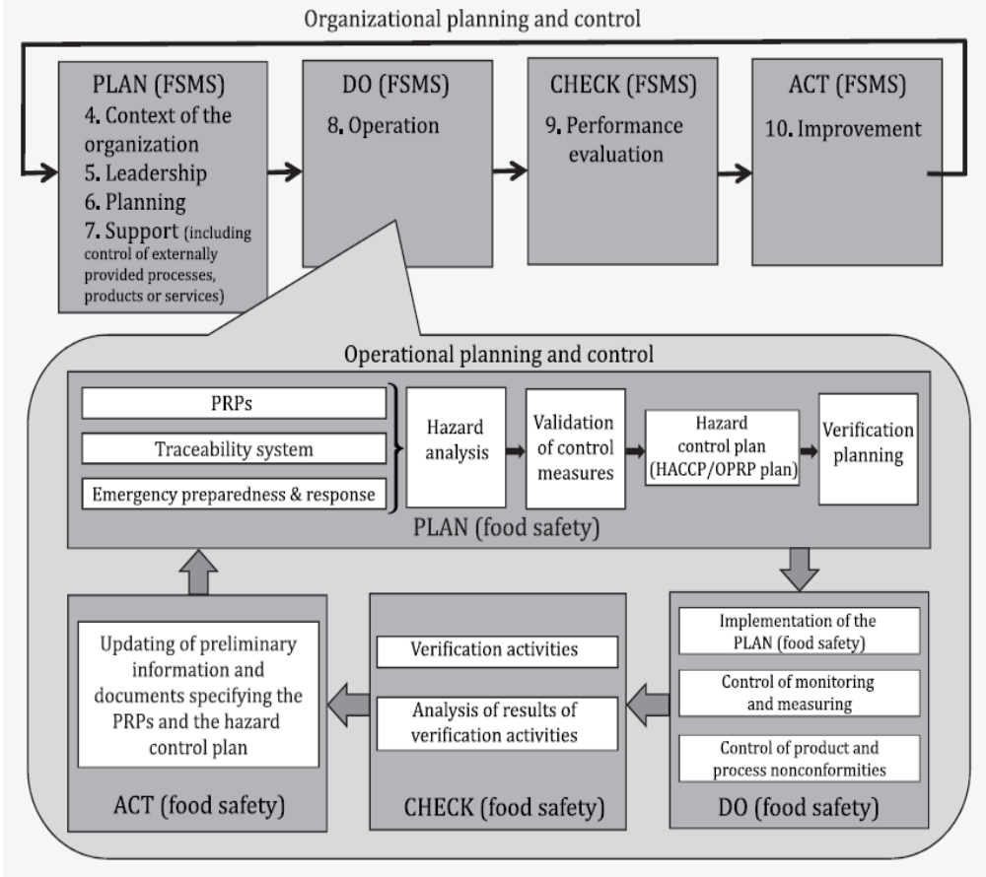

Source: ISO 22000:2018 Standard

4. Context of the organisation

- Understanding the organisation and its context
- Understanding the needs and expectations of interested parties
- Determining the scope of the food safety management system
- Food safety management system

5. Leadership

- Leadership and commitment
- Policy
- Organisational roles, responsibilities and authorities

6. Planning

- Actions to address risks and opportunities
- Objectives of the FSMS and planning to achieve them
- Planning of changes.

7. Support

- Resources
- Competence
- Awareness
- Communication
- Documented information

8. Operation

- Operational planning and control
- Prerequisite programs (PRPs)
- Traceability system
- Emergency preparedness and response
- Hazard control
- Updating the information specifying the PRPs and the hazard control plan
- Control of monitoring and measuring
- Verification related to PRPs and the hazard control plan
- Control of product and process nonconformities.

9. Performance evaluation

- Monitoring, measurement, analysis and evaluation
- Internal audit
- Management review

10. Improvement

- Nonconformity and corrective action
- Continual improvement
- Update of the food safety management system.

